# LearnPro Community User Guide

This guide is for people who live and work in Gloucestershire, to register for access to E-learning programmes and Face to face Training Courses supplied by Gloucestershire County Council Multi-Agency department.

To register for a personal account you will need a **unique Email address.**

**On LearnPro you can access the following:**

|  |  |  |
| --- | --- | --- |
| E-Learning modules:   * Basic Mental Health Awareness * Better Health / Better Lives (Learning Disabilities) * Continence * Dementia * Deprivation of Liberty Safeguards (Dols) * Domestic Abuse * Food, Safety, Infection Control, Nutrition & Hydration * Mental Capacity Act * Personal Assistant Induction * Safeguarding Adults Under the Care Act * Stroke Pathway * Understanding Autism |  | **Face to Face Training Courses:**  Available For **non GCC delegates**   * Autism Spectrum Condition Awareness * Mental Capacity Act Level 3 for Multi-Agency Managers * One Day Dementia Training * Responding to People in Mental Health Crisis * Safeguarding Adults Level 3 * Supporting Adults with Autism level 2   Available For **GCC Staff Only**:   * Dementia for Social Workers, Social care Assessors & Support Planners * Mental Capacity Act Level 2 ** * Mental Capacity Act Level 3 for Adult Social Care Practitioners * Safeguarding Adults Level 2**   For **GCC & 2NGHSFT Staff only**   * Autism training for staff undertaking Social care Assessments * Chairing Safeguarding Meetings * Domestic Abuse * Self Neglect * Safeguarding Adults Level 4 |

** for non GCC Staff please email [proudtolearn@gloucestershire.gov.uk](mailto:proudtolearn@gloucestershire.gov.uk) for details on how to access this training.

If you have any queries regarding registration difficulties or course availability, please get in touch with the team on [proudtolearn@gloucestershire.gov.uk](mailto:proudtolearn@gloucestershire.gov.uk)/ 01452 324306.

Step 1: **Registration – Please open this link in your web browser**

<https://community.learnprouk.com/lms/guest_level/RegistrationLocationAndRole.aspx?RegId=188>

Select the service description that best fits your organisation. If you cannot find one that fits please select ‘Other’ and press the ‘CHOOSE’ button on the right.

Some larger organisations such as 2gether NHSFT, Gloucestershire Care Services NHS and GFRS have their own description – **please only choose these options if you work for these organisations.**

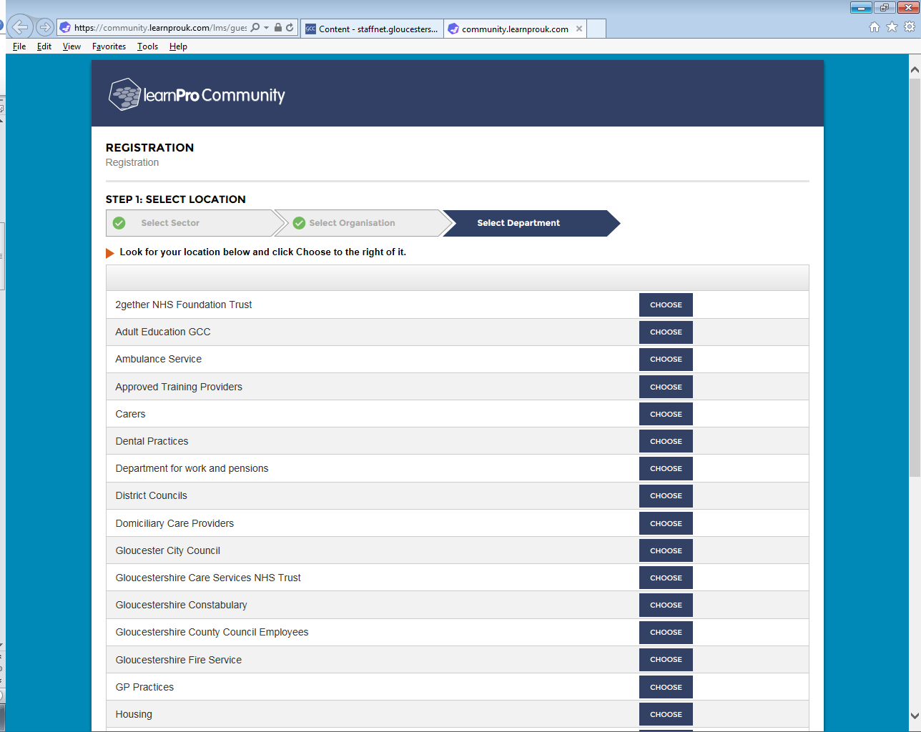

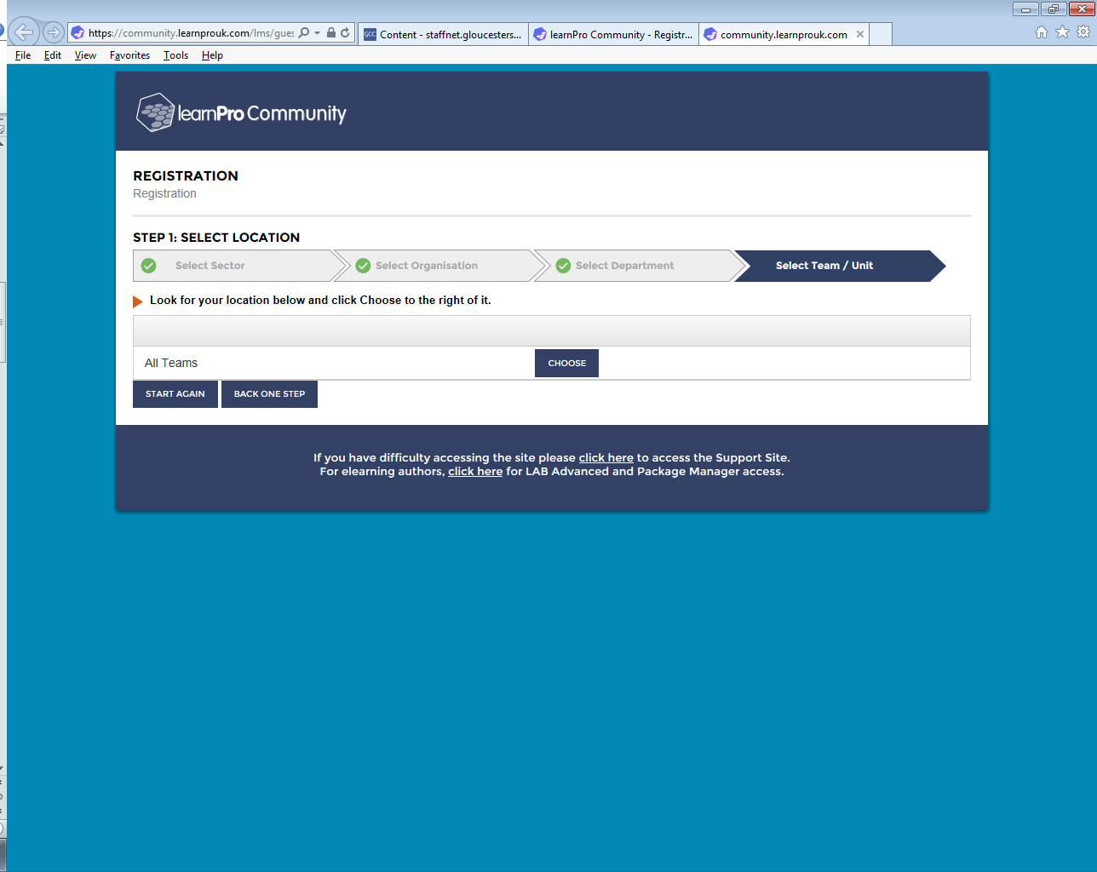You will then view the following page. Please select ‘Choose’.



Then Confirm and continue:

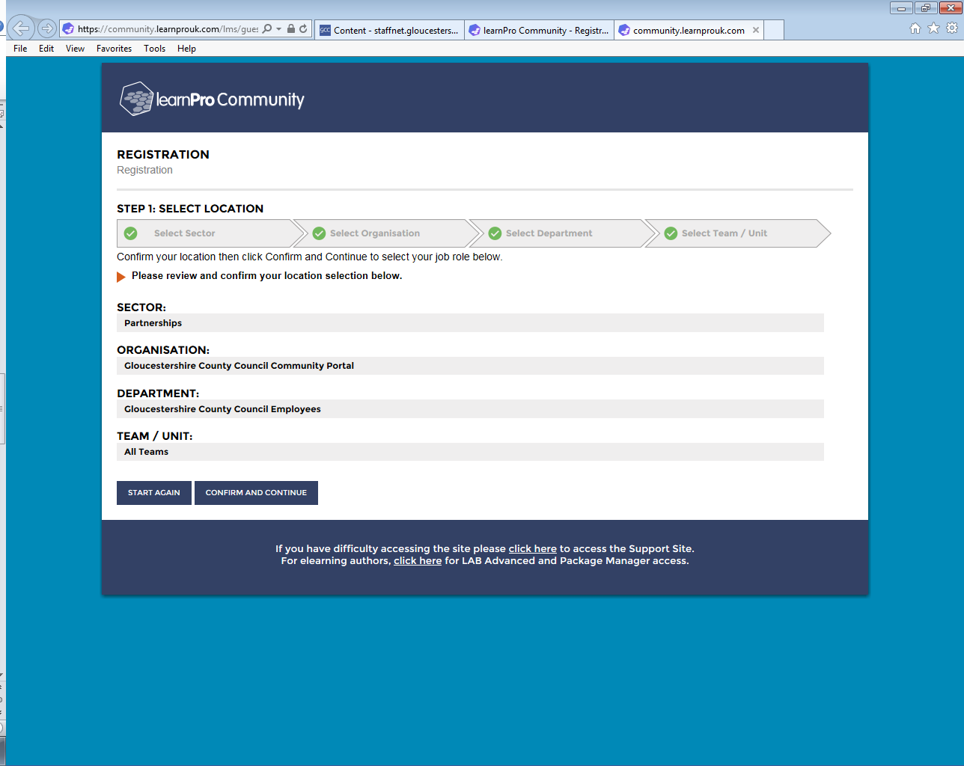

Then Confirm and continue once more:

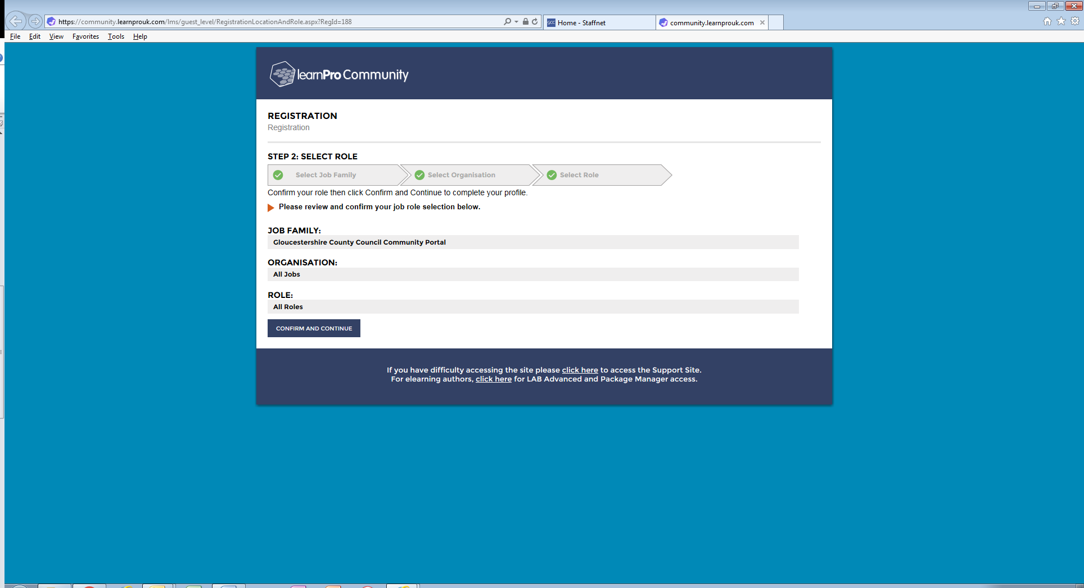

Step 2: **Personal Details**

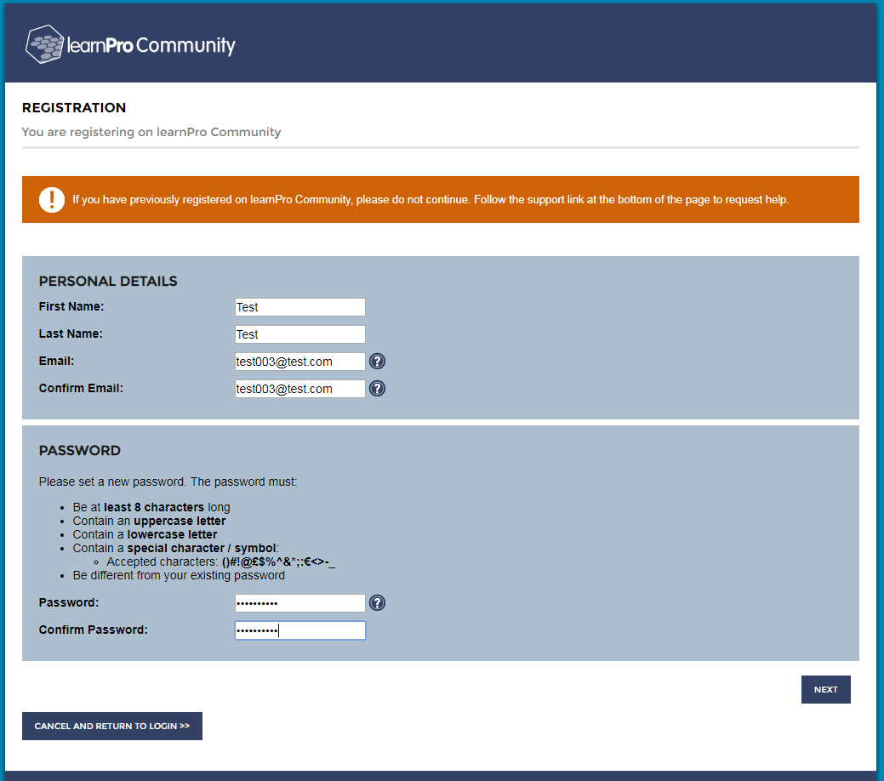Complete all of the fields and click ‘Next’ to continue registering.

All users **MUST** register with an **INDIVIDUAL** email address. If you do not have an individual email address you can set one up in less than 10 minutes through various hosts such as Google, Microsoft or Yahoo.



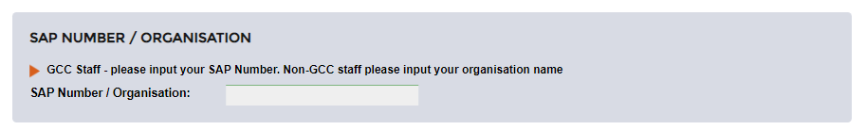Then **NEXT**



**Type in your organisations name / SAP Number** - If you are/work for a multi-agency partner please type in the name of your organisation. If you are completing this as an individual then use your own name. If you are a Gloucestershire County Council Employee please insert you SAP / Personnel number (you can find this on your payslip).

*Please note that you will not be able to put a space in this field.*

**Step 3: Logon to access.**

You will need to accept LearnPro’s Terms and Conditions on your first time accessing the modules.

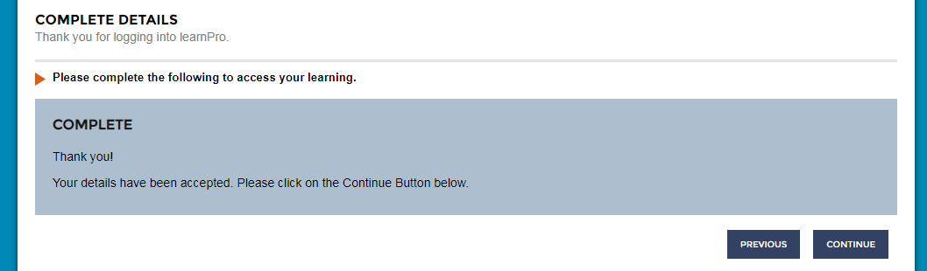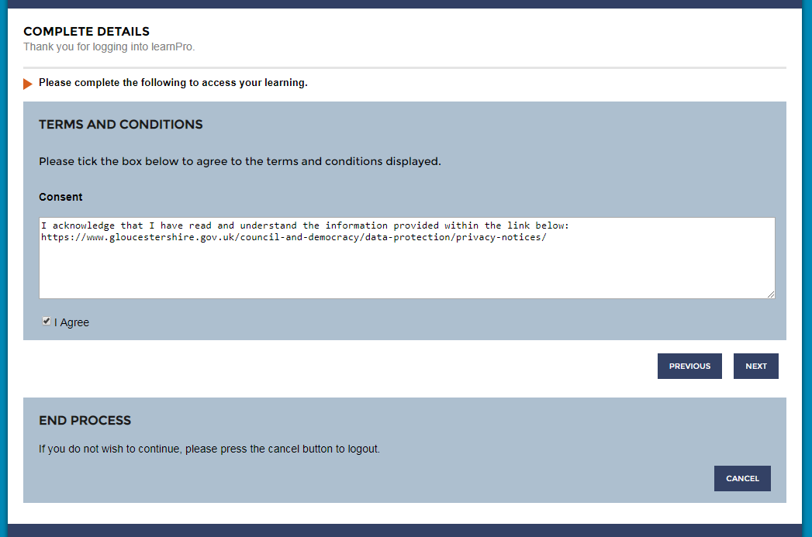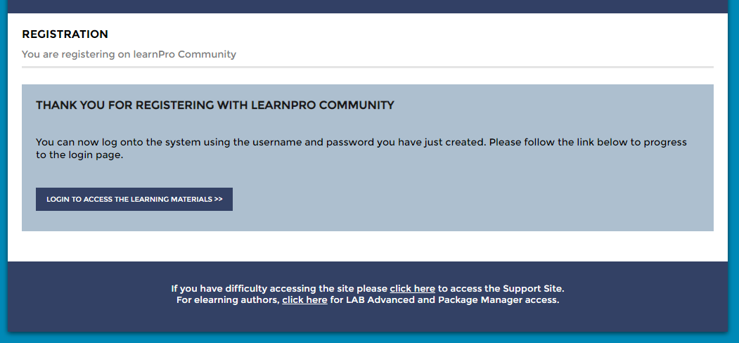

**Step 5: Complete registration**

**Step 4: Logon to access.**

Accept Terms & Conditions





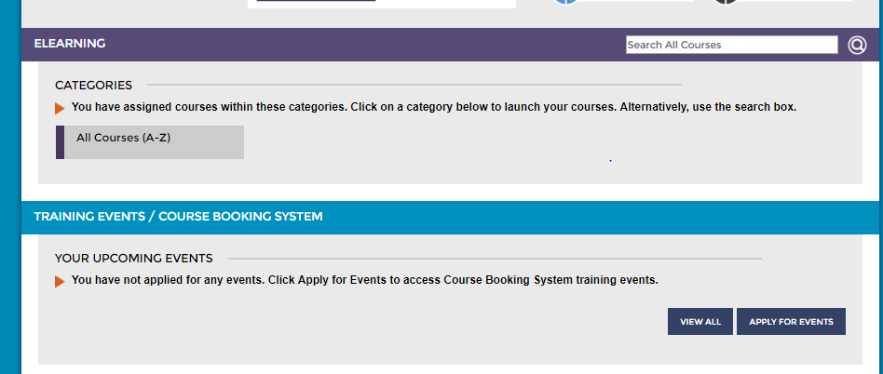

**Step 6: Choose whether you wish to access E-Learning Modules or Face to Face Training**

To access E-Learning select ‘All Courses A-Z’

If you wish to access face to face training events select ‘Apply for Events’.

**How do I book?**

1. On the home screen select the Apply for Events button in the Training Events Section.
2. Scroll through available courses to find the course you are looking for, choosing a date and location that is convenient for you, click select on that date.
3. More details about the course will appear. To request attendance on the course click book on event, this will be reviewed and authorised by an administrator.

If you experience issues when booking onto a course please get in touch by contacting us on 01452 324306 or email proudtolearn@gloucestershire.gov.uk

**Can I book other people from my organisation on training?**

Yes, using the ‘Line Management’ function on LearnPro you will be able to book individuals you ‘line manage’ onto training and view the training they have been on. To turn on this function please email [proudtolearn@gloucestershire.gov.uk](mailto:proudtolearn@gloucestershire.gov.uk) with the details of your account and the details of all the registered users you would like to ‘Line Manage’.

**How do I cancel?**  
If cancelling a place is unavoidable, you need to cancel the booking by contacting us on 01452 324306 or email proudtolearn@gloucestershire.gov.uk. Due to the high number of last minute cancellations and non-attendance there will be a charge for cancelling confirmed places on courses. If you cancel within 10 working days of the event, or do not attend on the day, a charge of £75 per day or £40 per half day will be made. This applies whatever the reason for cancellation.