BMJ Learning- access for SWASFT staff and students

BMJ Learning comprises over 700 short, interactive e-learning modules on clinical subjects for professionals wishing to keep up-to-date with bite sized chunks of learning.

YOU WILL INITIALLY NEED TO COMPLETE THE BMJ LEARNING FIRST TIME REGISTRATION (as below)
You can then login with OpenAthens via ANY internet enabled device at
http://learning.bmj.com/learning/Athens.html

BMJ Learning first time registration:

- If you don’t already have one Register for an NHS OpenAthens account at http://openathens.nice.org.uk/ Note-If you already have an OpenAthens account go to step 2.

-Register on SWASFT networked machine or enter NHS email address to gain instant registration (if not you will have to wait for confirmation of eligibility from Athens admin team)
-Enter SWASFT in the ‘Please enter your organisation’ box (as below) and wait a couple of seconds for the option SWASFT (South Western Ambulance) to appear
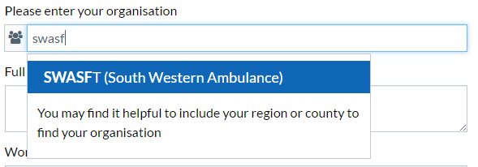
-Once form is completed you’ll receive a confirmation email including a link to setup your password
- Login with your OpenAthens account at http://learning.bmj.com/learning/Athens.html
-Note: You can use your email address as your Athens username

- Register for a BMJ Learning account- this account allows you to personalise & save learning.
Once you have completed this initial registration you should always login with your OpenAthens account details – your BMJ Learning account will be automatically linked to it.

-You will be asked to enter your email address and select a password
-You can also: Select the option to ‘Complete your profile’. This allows you to select a job role & you will then be given suggestions for relevant modules when you login.
To select Paramedic first select Other Healthcare Professional (as below)

