Microsoft Teams User Guide
Joining
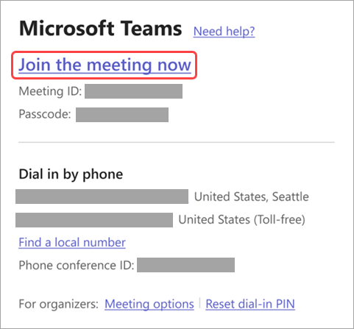
You will have been sent an email to your SWAST email address, in there you will need to select Join the meeting now to join on Teams for web or desktop.

Using Video
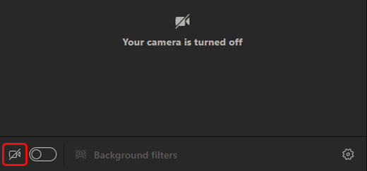
To turn on your video before a meeting, turn the Camera toggle on before you join.

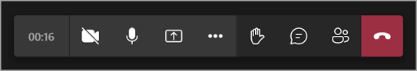
To turn your video on and off during a meeting, select Camera in the meeting controls.

Mute/Unmute Mic
When you join a Teams meeting, you can choose to mute your mic to prevent any unwanted noise or unmute your mic to participate in the meeting.
There are a few different ways you can mute or unmute your mic in Teams.
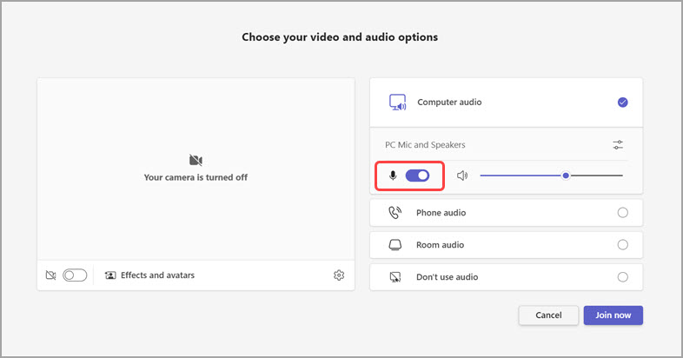
Before joining a meeting, you can turn your mic on or off by selecting the Microphone toggle.
To mute your mic during a meeting, select Mic in your meeting controls. To turn your mic back on, select Mic .
Using Chat
View and send messages in a meeting chat. When someone sends a new message, a red dot will appear on Chat in the meeting controls.

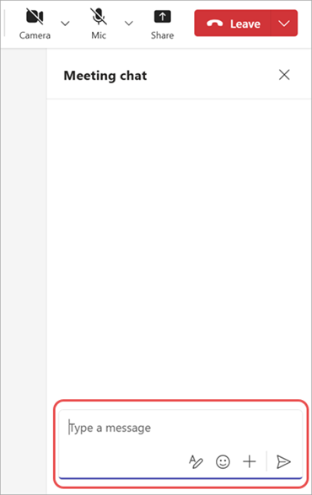
- Select Chat in your meeting controls.
- In the Meeting chat pane, view messages that have been sent and see who’s typing in real-time.
- Type your message in the compose box.
- Select Send Teams chat send button icon to send your message in the chat.

Raising Your Hand to Talk
During a meeting, you can raise your hand virtually to let people know you want to contribute without interrupting the conversation.
In the meeting controls at the top of the screen, select Raise . Everyone in the meeting will see that your hand is raised.
Meeting presenters will also receive a notification that your hand is raised. In meetings where attendees can't unmute themselves, a presenter can allow you to unmute.
If using the iOS or Android version of toolbar, see the reactions section for guidance.
Reactions
In addition to virtually raising your hand in a Teams meeting, you can express yourself in other ways to help make Teams meetings more inclusive, engaging, and fun!
For Desktop Versions:
During your meeting, select React in the meeting controls at the top of the meeting view to share your reaction to what's being shared. Choose from a range of live reactions, including:
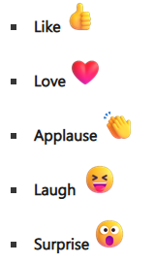
For Mobile Versions:
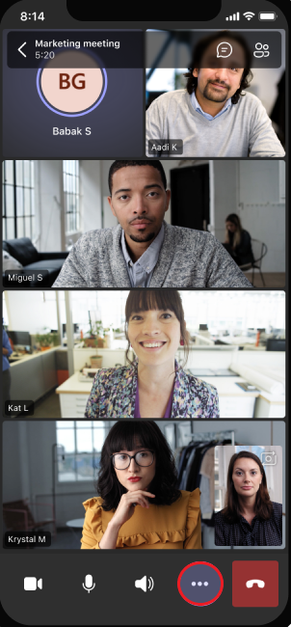
To share meeting reactions (or raise your hand) when you’re using an iOS or Android mobile device while in a Teams meeting, tap More info in meeting controls along the bottom of the screen to choose a live reaction.
The reaction will pop up momentarily across your live video feed, or if your camera is turned off, across your profile picture.

Breakout Rooms
When you join a breakout room during a Microsoft Teams meeting, you’ll be able to participate in activities and discussions with a smaller group of participants.
If your room was assigned, you’ll join it automatically when the room opens. When you join the breakout room, your camera and mic will be turned off until you turn them on.
Each breakout room has its own chat. After you join a breakout room, select Chat in your meeting controls to view and send messages in that room. Meeting organizers can view and participate in any breakout room chat from their main Teams chat list.
If your breakout room session expires or your meeting organizer closes your room, you’ll automatically return to the main meeting. If the room settings allow it, you can also return to the main meeting anytime by selecting Leave room in your meeting controls.

