# Recovery Navigator Service (In Partnership with SWASFT)

Recovery Navigation builds on existing work between Primary Care, Second Step and other voluntary sector partners.

The Recovery Navigators will work with patients who are struggling with moderate to high enduring mental health difficulties and who are registered to GP practices within Bristol, North Somerset and South Glos (BNSSG).

It has been acknowledged that there is currently a gap between primary care and secondary mental health services for people struggling with their mental health. The voluntary services are there to help fill that gap and support people to find coping strategies personally and within their community.

This pilot will create a direct onward referral pathway through 999 via the SWASFT Mental Health Specialist Desk (MHSD) into the Second Step intensive community based mental health services for individuals identified as a high intensity user.

More information on the project; including aims, risk management, operational practice can be found within the Service Standard Operating Procedure (SOP)

Information for potential referrals

Second Step, a Mental Health Charity, are working in partnership with South Western Ambulance Service Foundation Trust (SWASFT) to provide a Recovery Navigation Service to support individuals who would are struggling with their mental health. The service can offer support such as:

* Development of a Wellness and Recovery Action Plan (WRAP) to identify triggers and strategies to maintain positive mental health
* Development of a Safety Plan around suicidal thoughts
* Develop coping skills for anxiety or depression
* Introduction to wellbeing activities (e.g. relaxation techniques, mindfulness, healthier lifestyle activities, etc.)
* Practical support to access appropriate services and community resources, including physical and nature-based activities.
* Referrals for safeguarding, if required.

If consent is gained to make a referral to the Recovery Navigation service, information on the referral form will be shared with the Recovery Navigation Service, including:

* Name
* Date of Brith
* Gender
* Contact details
* NHS Number
* Open to Secondary Care Mental Health services?

Guarantees of a service offer should not be made. If an individual consents to a referral, initial contact will be made by a Senior Recovery Navigator within 7 working days to arrange a date and time to have a conversation to assess suitability for the service, including discussions about ‘what matters to you’, identifying goals and to ensure support is individual to identified needs.

Information for Referrers

The service user cohort will be identified by the High Intensity User Group. This will be HIUs of SWAST. Active HIUs will be flagged on the Computer Aided Dispatch System (CAD) as potentially meeting the criteria for the project.

**Who we can support:**

* Are presenting with a primary mental health need
* Have a GP registered in Bristol, North Somerset & South Gloucestershire
* Are 18 years or over
* High Intensity Users (HIU) of SWAST.
  + The service will prioritise HIUs of 999 – the project defines an HIU as ‘an adult (18 years +) who makes 5 or more emergency or urgent calls in 1 month, or 12 or more in 3 months, from a private dwelling
* Have been triaged/assessed by MHSD as requiring self-care or signposting

**Who we can’t support:**

* Any person who the MHSD have not been able to triage/assess fully
* Are receiving support from secondary mental health services
* Are receiving support from the MINTs
* Individuals with a history of violent behaviour, posing a risk to others/self or requiring an enhanced level of security
* Individuals with a diagnosed learning disability and no mental health need
* Individuals with substance misuse issues with no known mental health disorder
* Individuals with a primary dementia diagnosis
* Individuals who are in custody at the time of their presentation to 999

How do I make a referral?

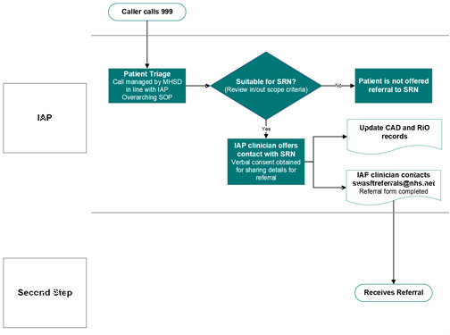

* Mental Health Service Desk (MHSD) Team receives a call from an individual and completes triage as normal.

**During MHSD Triage**

* If onward specialist MH referral is required, no referral made to Recovery Navigation (Refer to ‘who we can’t support’ section above)
* *If the individual is flagged on the CAD system as appropriate for Recovery Navigation*, MHSD provides brief overview of Recovery Navigation service (see Information for Clients section above)
* *The individual must consent to a referral.* MHSD team to complete a referral form (attached to the bottom of this document). Completed referral forms need to be sent to

[sshaltd.secondstep.swasftreferrals@nhs.net](mailto:sshaltd.secondstep.swasftreferrals@nhs.net)

* If a professional wishes to speak directly with the Senior Recovery Navigator for the project about and questions/queries for example, their contact details are

[caterina.scalesia@nhs.net](mailto:caterina.scalesia@nhs.net)