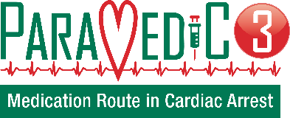

PARAMEDIC3 aims to evaluate the effectiveness of intraosseous first access in the treatment of out of hospital cardiac arrest measured by 30 days survival. Patients are randomised by the paramedic or student to either an intraosseous or an intravenous group using a randomisation envelope. Target recruitment is 35 enrolled patients per month. Enrolling a patient into research at the scene of the cardiac arrest is particularly challenging, so as a quick reminder.

- Any member of staff can open the envelope.
- Once you open the envelope, the patient is enrolled into the study, in any circumstance.
- Anyone trained can gain access.
- Clinical judgement takes priority over research.
- If the randomisation method allocated will delay care, appropriate access should be gained at the paramedic discretion.
- If the randomisation method is different to the access gained, the patient is enrolled, we can still use this data.
265 patients have been enrolled and ten of the survived patients have agreed to provide information on their health-related quality of life over the next 6 months.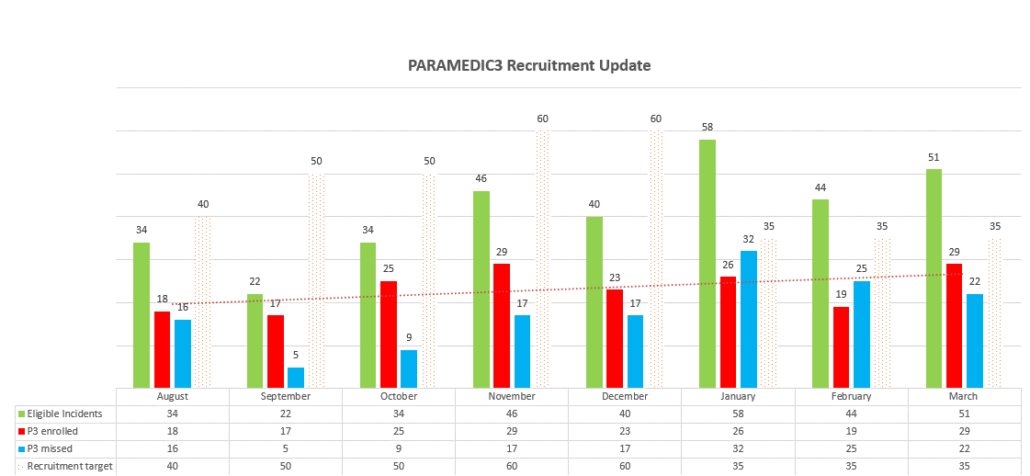
We are very nearly on target! Envelopes are individually allocated to those who read the training poster: PARAMEDIC3 TRAINING POSTER and complete the quick assessment PARAMEDIC-3 assessment (office.com) If you feel you would be able to enrol a patient in a cardiac arrest event, please do complete the training.

Warwick Clinical Trials Unit host PARAMEDIC3, and they have recorded a series webinars to support staff learning. Many of you requested a video recording of the webinar. Below are the links as well as links to the CPD certificates.

Webinar- 3rd April 2023
Presentations: PARAMEDIC-3 trial update- Keith Couper; Human factors in cardiac arrest- Stef Cormack; Cardiac arrest in children- Barney Scholefield
Link to webinar video: https://estream.warwick.ac.uk/View.aspx?id=71485~5m~f5AuXecwPg&code=tz~MlUYs6qGI2Rhsqq7wdDUG3vahbK9nOUmcL7UOsNWkMi3rbBxsGUDEm8q&ax=7z~H8fPpiTOMCccdC
CPD certificate link (final page of evaluation): https://warwick.co1.qualtrics.com/jfe/form/SV_4NtIsoi0It8FfD0

Webinar- 26th January 2023
Presentations: PARAMEDIC-3 trial update- Keith Couper; Cardiac arrest in COVID-19: lessons for the future- Ali Coppola; Managing refractory VF- defibrillation strategies and drugs- Charles Deakin.
Link to webinar video: https://estream.warwick.ac.uk/View.aspx?id=67136~5k~cFWyC0GUUr&code=tA~mVjoc5C2eQKzQgQNCN6ls2juRKkC7KAjzcEQPShmrVv5AeU9xXBGwPFo&ax=7G~oRiMjIsOVairkS
CPD certificate link (final page of evaluation): https://warwick.co1.qualtrics.com/jfe/form/SV_26n0Iy8f44km56u

Webinar- 8th August 2022
Presentations: The PARAMEDIC trials: the success of UK pre-hospital cardiac arrest research- Gavin Perkins; Drug route in cardiac arrest: ongoing uncertainties- Jerry Nolan; Traumatic cardiac arrest: pre-hospital management- Caroline Leech
Link to webinar video: https://estream.warwick.ac.uk/View.aspx?id=61370~5e~WIi0rIs4iC&code=tJ~74RtryxPieDoRYr0IPni8okTavUTnJgfnHisbCH7CgGbaOaHrIqliSiV&ax=7J~T3ckoT9JmSPvDc
CPD certificate link (final page of evaluation): https://warwick.co1.qualtrics.com/jfe/form/SV_e3Z9eJCAXymuq7s

