Level 3 Diploma in Award in Education and Training
PLEASE COMPLETE
The information requested below is mandatory as we now provide an accredited qualification. Failure to provide this information will result in you not being booked on the course.

Full name of candidate:

Gender: Female/Male (delete not applicable)

SWASFT Email Address:

Date of Birth: Ethnic Code: (see table below)

Base Station: Area: NORTH / EAST / WEST (delete not applicable)

Mobile Telephone Number

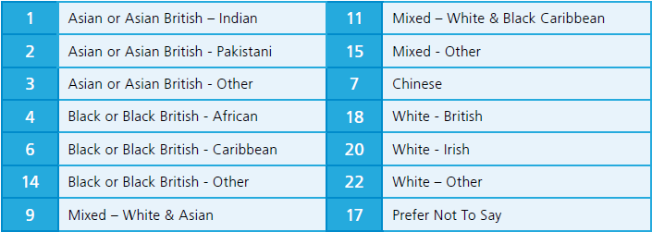

Disability code: (see table below)

