DLS IT Skills Pathway Learning Menu
Quick Start Delegate Guide

- Click on the Digital Learning Solutions link https://www.dls.nhs.uk/Home
- Login using your registered delegate ID and password or register to create your delegate ID and password

Need Help? Find your local contact details at the bottom of this resource

- Ask for resource DLS018 for help with registering and setting secure passwords
- Don’t remember your password? Click Recover at login – resource DLS020
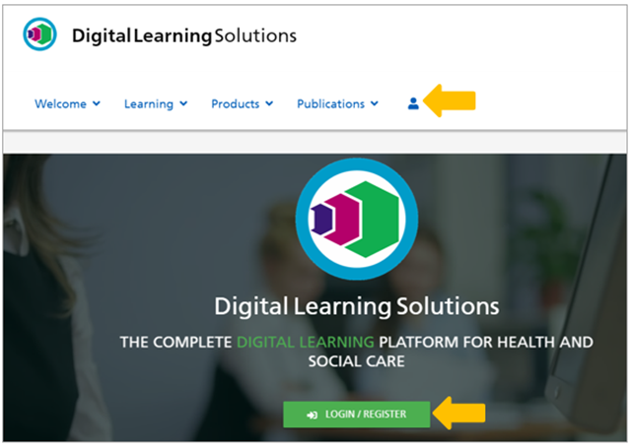

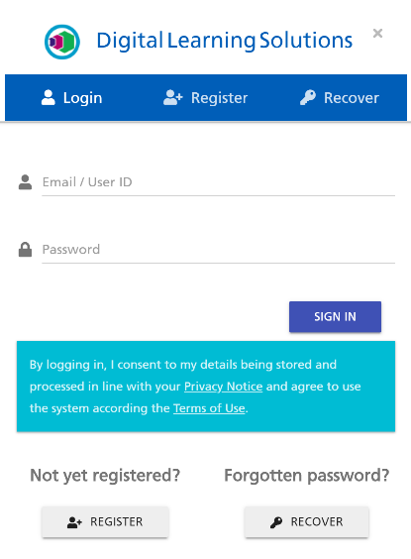

- Access your course (this may be via the Learning Portal) to see the Learning Menu

- for further guidance about using the Learning Portal please ask for resource DLS009 or access the system help

Important: Need help? scroll to the bottom of the Learning Menu for your local contact details, alternatively they are available at the end of this resource.
You’ll also see the Terms of use, Accessibility and Privacy notices here.
- Video demonstrations are available which explain how to undertake the Diagnostic (skills check), Learning and Post Learning Assessments:
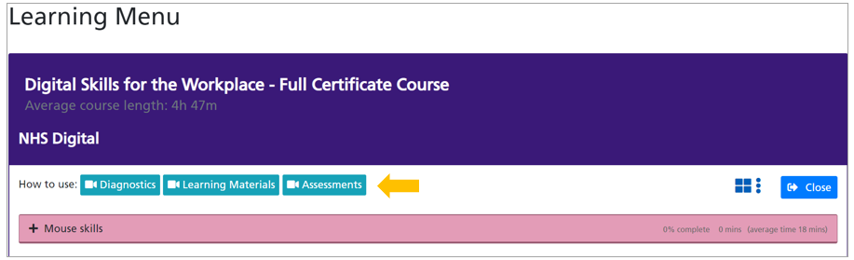
- We recommended that you watch the videos if this is the first time you have used the materials

- Click on the module you want to start learning and the menu will expand to show all the tutorials and the assessments:

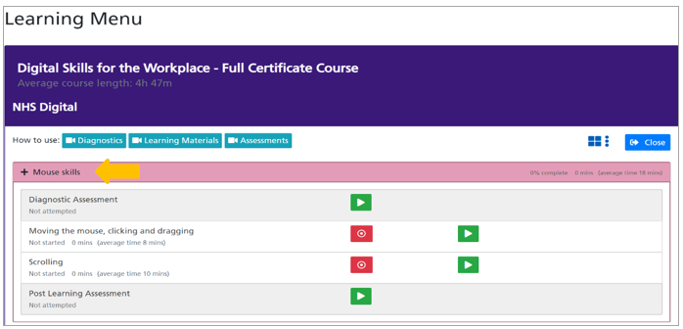

- You can now access your learning materials:
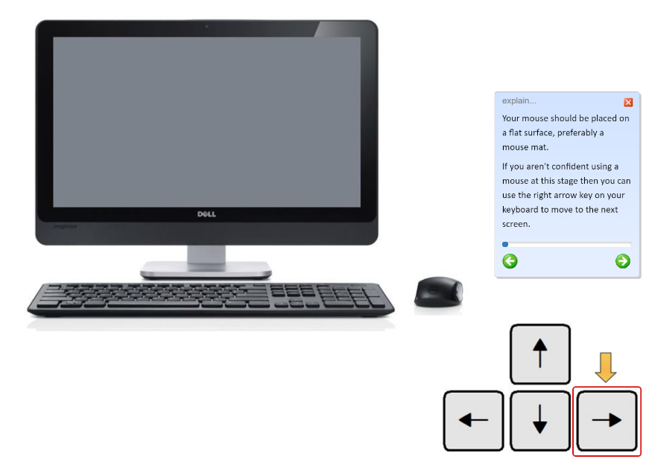

- When you return to the Learning Menu you can check your progress and view a Summary:

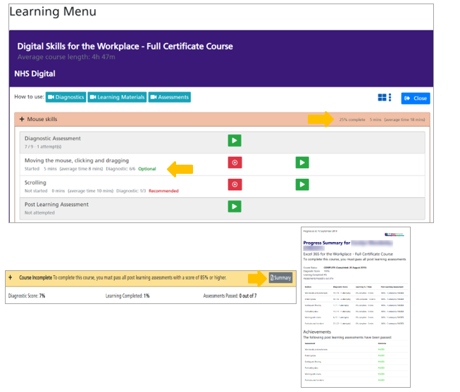

- When you’ve completed all the criteria to pass the course the Evaluate and certificate button becomes available

- NOTE: Certificates are only available for courses that include Post Learning assessments and can only be accessed after submitting an evaluation form (if applicable).

- Once you’ve evaluated the course your certificate becomes available:
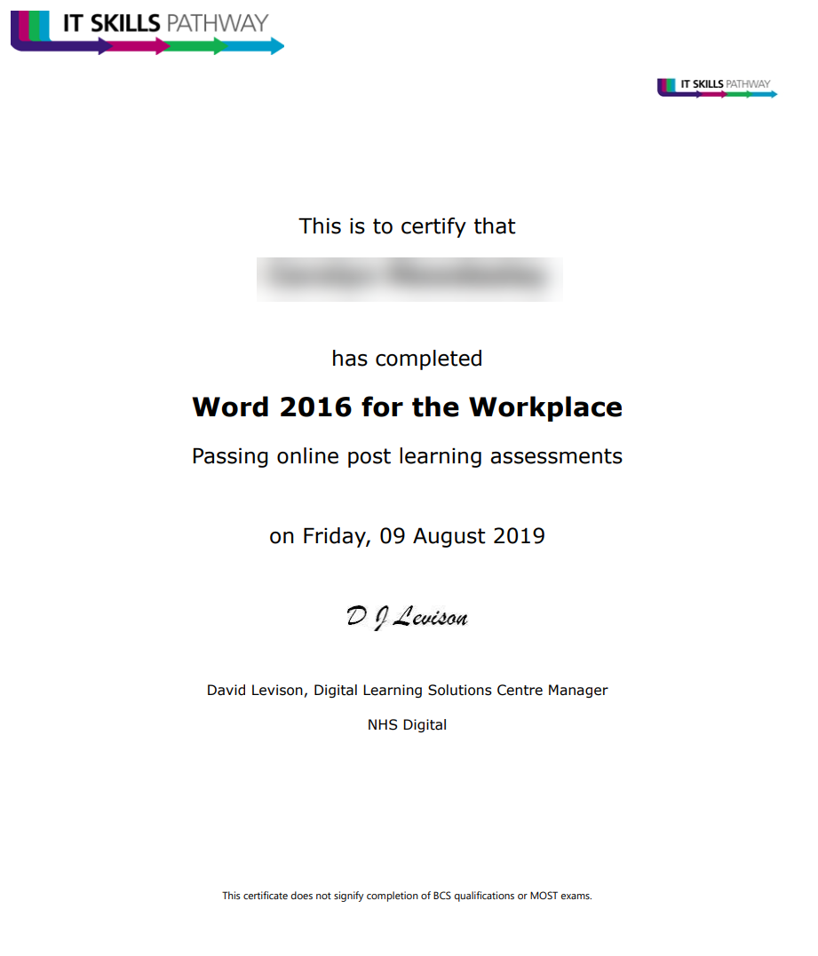

- To Manage your Account, click the Application Selector icon
- To Close the Learning Menu, click the Close icon

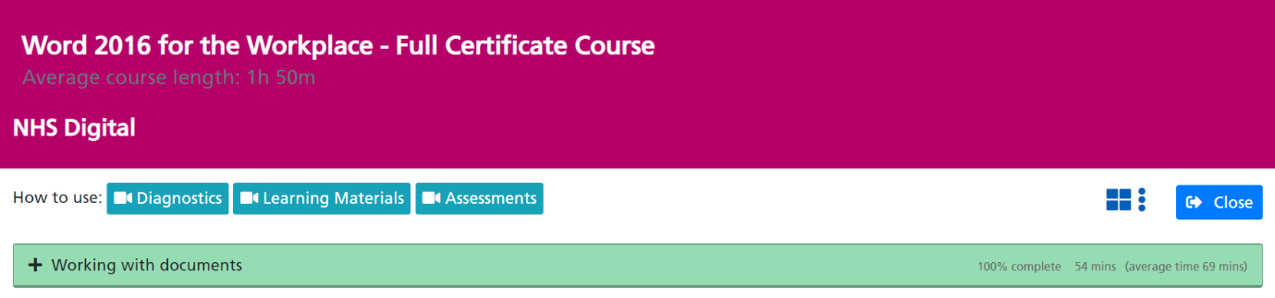
Minimum Technical Requirements
- Windows XP SP2 or newer Operating System
- Internet Explorer 9 or newer (or other modern browser)
- Minimum screen resolution 1024 x 768 (recommended 1280 x 1024 or 1920 x 1080)
It is also essential that the Tracking System address https://www.dls.nhs.uk is added to your Trusted Sites list to prevent security settings blocking calls to the Tracking System (ask your IT team for support getting this in place across the organisation).
If you are accessing IT Skills Pathway legacy Microsoft Office Content (Entry Level, Level 1, Level 2 and Level 3 content) Adobe Shockwave Player 12.x is required and we’d recommend updating to a “for the Workplace” course.

For HELP contact your local administrator here:

