It happens to us all, from time to time we forget and it couldn’t be easier to Recover your DLS password. Just follow the steps in this simple guide….

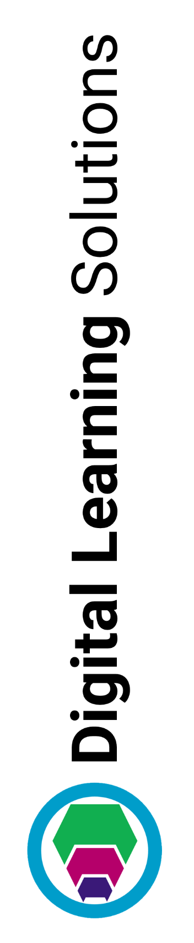
- From the Login screen, click Recover

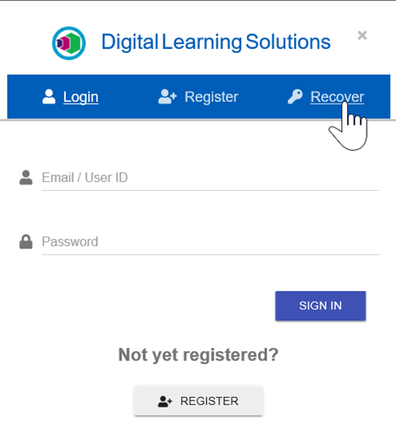

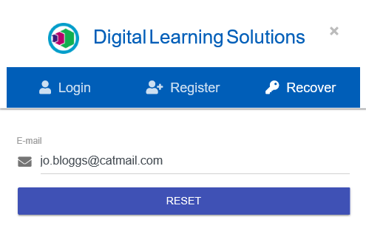
- Type in your registered E-mail address and click RESET

- You will receive the following message, click OK
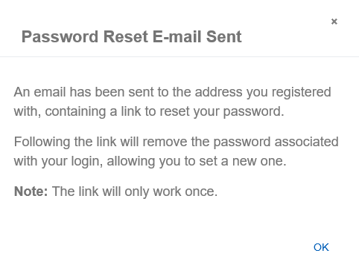

- Go to your email account and follow the link in the email
If you do not receive an email check your junk folder to see if it has been delivered there
A request has been made to reset the password for your Digital Learning Solutions account.

To reset your password please follow this link: https://www.itskills.nhs.uk/landing-preview/reset?pwdr=2186b85f-1272-4ee9-9ff2-74c8f582e032&email=Joe.Bloggs@catmail.com
Note that this link can only be used once.

Please don't reply to this email as it has been automatically generated.

- Enter a New Password, then Re-type Password and click RESET PASSWORD

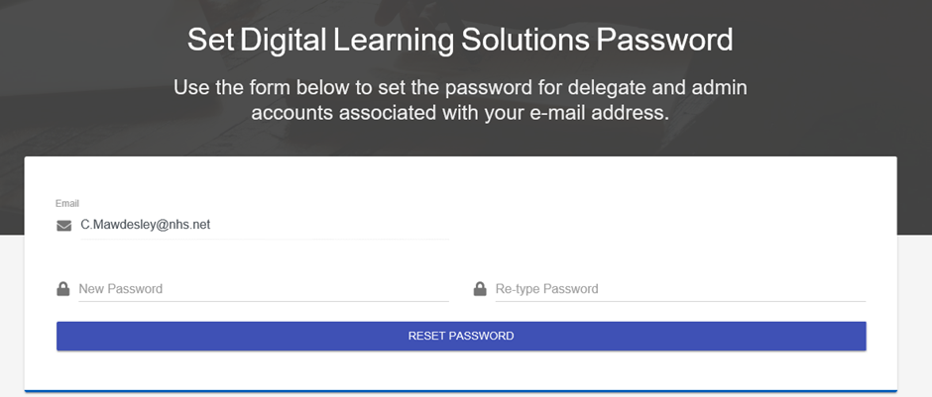
Should you still be experiencing issues after following the Recover process, please contact your local administrators:
Add centre contact details here:

