It’s easy to self-register for learning, either click the link provided by your centre or go to:
https://www.dls.nhs.uk

- Click the Icon or LOGIN / REGISTER button
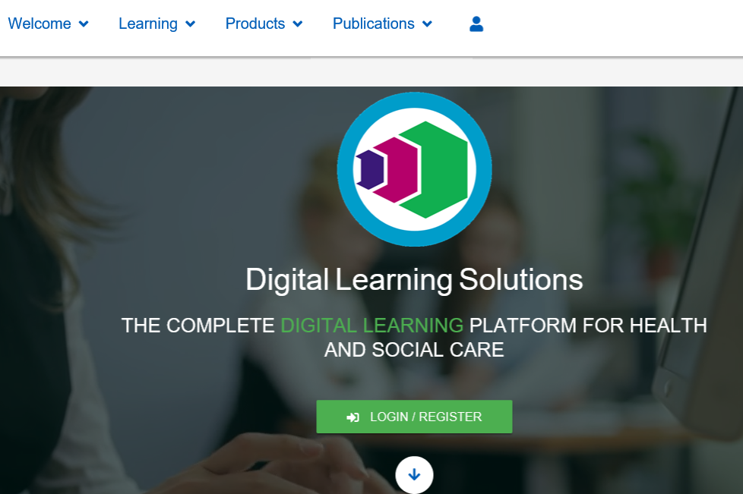

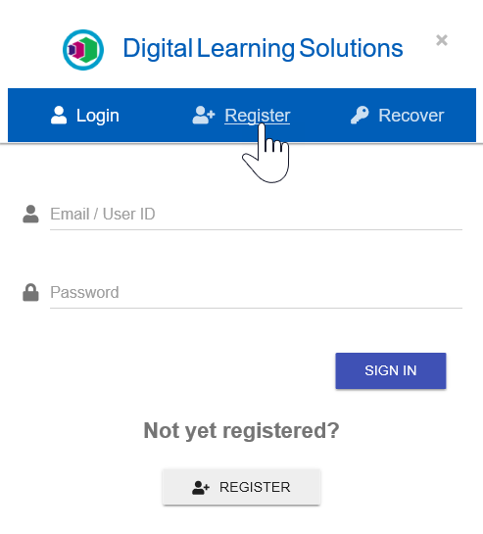

- Click Register

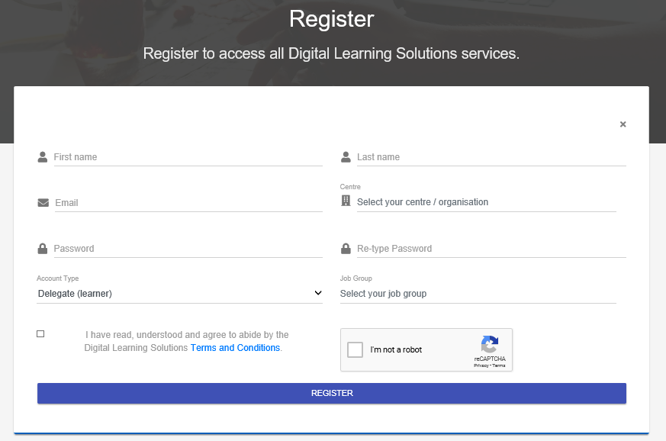
- Complete the registration form, then click REGISTER

Important information for the registration process:
Select your centre / organisation: – this should be pre-selected for you, if not carefully select your centre from the list provided ensuring you select your organisation
Password: Your Password will need to be 8 characters long with 1 letter, 1 number and 1 symbol
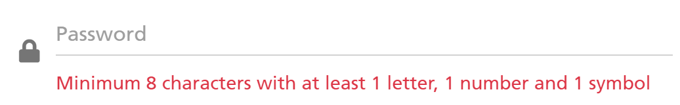
Account Type: always select Delegate (learner) this should be pre-selected for you
Terms and Conditions: You must tick to accept the terms and conditions if you want to continue
I’m not a robot: Tick to play a quick game that helps to identify you as a human not a robot!
NB: reCAPTCHA is an American tool that helps to protect from automated activity. You will be asked to identify objects such as “sidewalks” which as you probably know is a pavement in England! You may occasionally be asked to identify several objects, stick with it you’re almost there….

Please Note: If you are registering outside of your place of work you will be notified that your registration will require approval
There may also be some additional information required by your centre to complete the registration
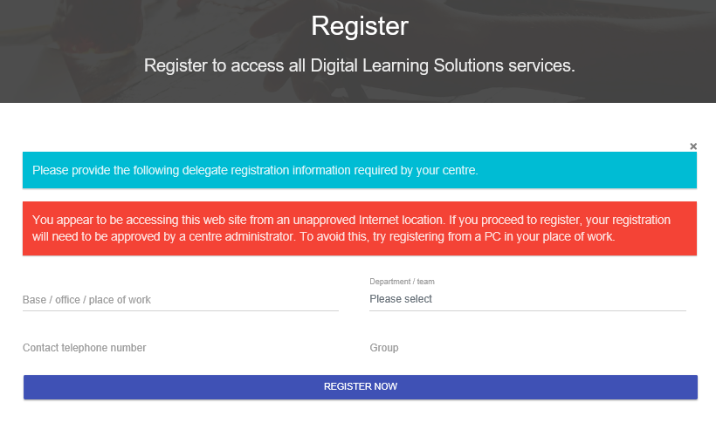
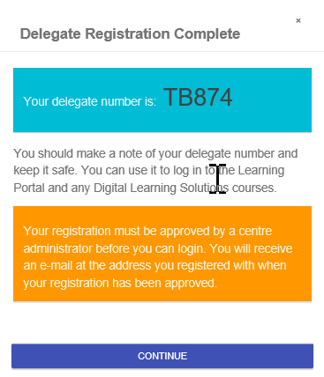
Click REGISTER NOW

- You’ll receive your delegate number, please make a note of this

Please note: If your registration requires approval an email will be sent to your registered email account once the registration is approved.

- Click CONTINUE

- That’s it, you can now Login using the credentials you set up at self-registration
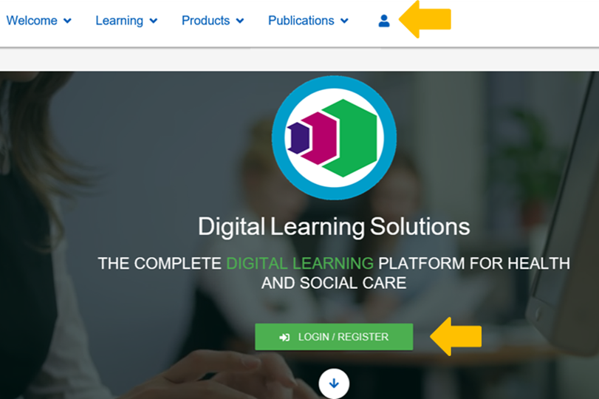

Contact your local centre for support
Centre Contact Details

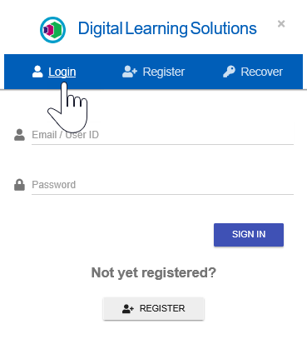

- Enter your User ID and Password and click SIGN IN

