|  |
| --- |
| **Welcome to the Learning Portal** -*the quick and easy way to access your IT Skills courses, enrol on new courses, see your achievements and search the Knowledge Bank to learn new skills…*  1  To access the Learning Portal, go to: [https://www.dls.nhs.uk/learnerportal/Default?CentreID=###](https://www.dls.nhs.uk/learnerportal/Default?CentreID=) **Add your centre number here (this can be found on the Dashboard of the Tracking System)**  Type your **User ID** and **Password** in the appropriate fields and **Sign in**  If you need a reminderclick **Recover**  **I have previously accessed the Learning Portal**  **I’ve never accessed the Learning Portal**  Before you start: Ask for resource **DLS018** **– Register and Set a Secure Delegate Password**, if you need help with this  2  Click **Register** to create an account and get access to the Learning Portal  You’ve reached the **Welcome** page of your Learning Portal from here you can:-   * Check and update your details by clicking on **My Details** * See your **Current** courses * Navigate to your **Completed** courses, enrol on **Available** courses and search the **Knowledge Bank** * **Log out**   3 |
| **Let’s explore the Learning Portal….**  **Diagnostic** Scores are displayed here  Hover over these icons to see the **Course Content**  From the **Current** tab you can see any courses you are currently enrolled on. You can launch your learning from here.  **Assessment** Passes are displayed here  Click to sort by column headings  **Launch** courses here  From the **Completed** tab you can see your achievements, evaluate the courses and print your certificates.  **Launch** the course to recap here  Hover over these icons to see the **Course Content**  See your **Diagnostic** and **Assessment** passes here  **Evaluate** the course and print **Certificates** here  Click to sort by column headings      From the **Knowledge Bank** you can search for bite-size tutorials and videos.  Type your **Search** here  Use the **Filters** to refine the results  Then click **Go**  The results will appear here, you can click to launch **videos** and **tutorials**  There may be a number of pages of results depending on your search. You can view all the results by clicking on the numbers here |

Click this button to **re-enrol** on a course you have previously started and not visited for a while. The course is now available in **Current**

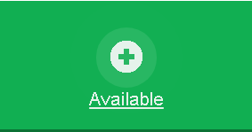

From the **Available** tab you can book directly onto other courses that may be of interest to you. If there is a course you’d like to do and you can’t see it here please contact us.

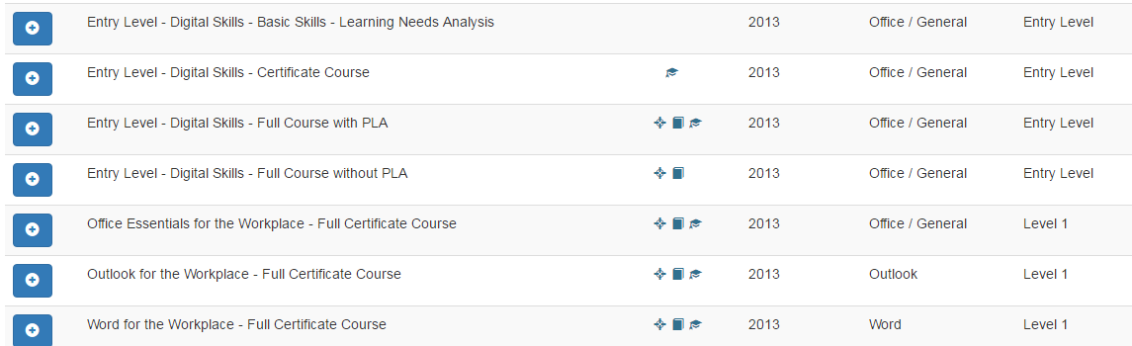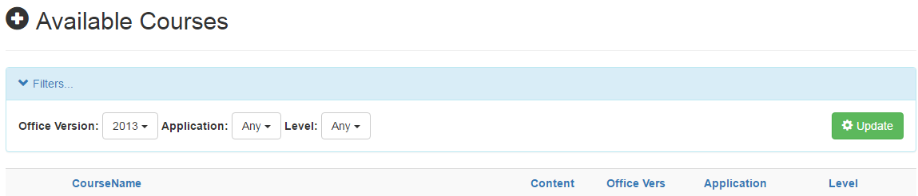

Click to sort by column headings

Apply **Filters** to search for courses and then click 

Click on the course enrol button to start a course. The course is now available in **Current**

Hover over these icons to see the **Course Content**

**Office Version**, **Application** and **Level** are displayed here

When you’re ready to leave the Learning Portal you’ll need to **SIGN** **OUT**

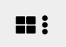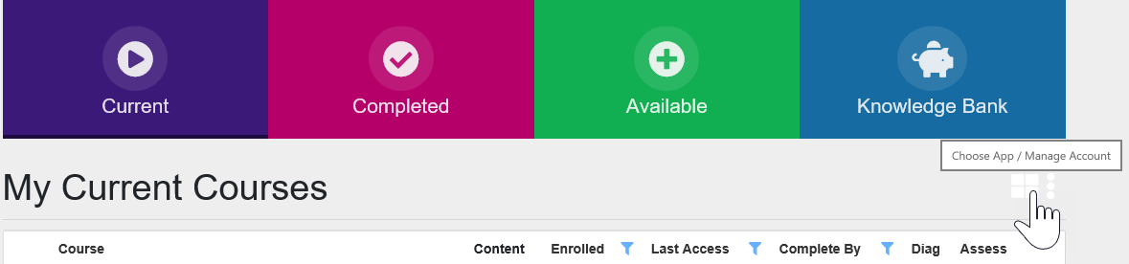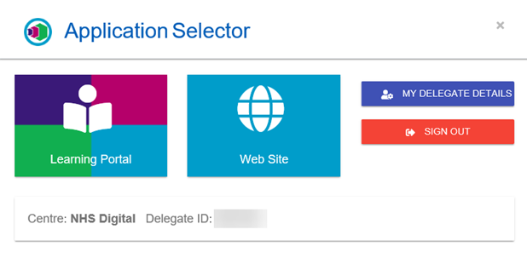

Then click **SIGN OUT**

To return to the **Application** **Selector** click here

From **MY DELEGATE DETAILS** you can set your notification preferences and manage your password

Access the Digital Learning Solutions Web Site here

Changed your mind? Return to your Learning Portal here