Welcome to the Learning Portal - the quick and easy way to access your IT Skills courses, enrol on new courses, see your achievements and search the Knowledge Bank to learn new skills…

1

To access the Learning Portal, go to: https://www.dls.nhs.uk/learnerportal/Default?CentreID=### Add your centre number here (this can be found on the Dashboard of the Tracking System)

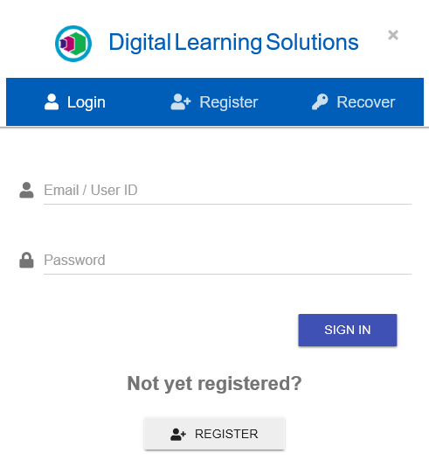

Type your User ID and Password in the appropriate fields and Sign in
If you need a reminder click Recover
I have previously accessed the Learning Portal
I’ve never accessed the Learning Portal
Before you start: Ask for resource DLS018 – Register and Set a Secure Delegate Password, if you need help with this
2

Click Register to create an account and get access to the Learning Portal

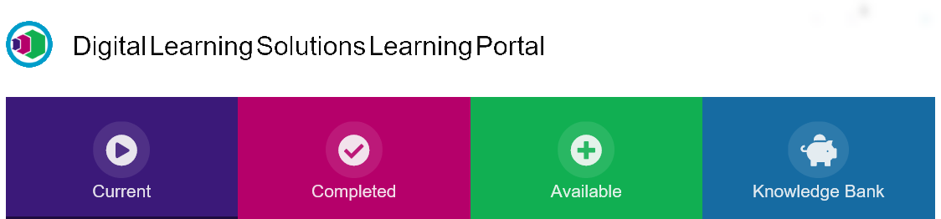
You’ve reached the Welcome page of your Learning Portal from here you can:-
- Check and update your details by clicking on My Details
- See your Current courses
- Navigate to your Completed courses, enrol on Available courses and search the Knowledge Bank
- Log out

3

Let’s explore the Learning Portal….

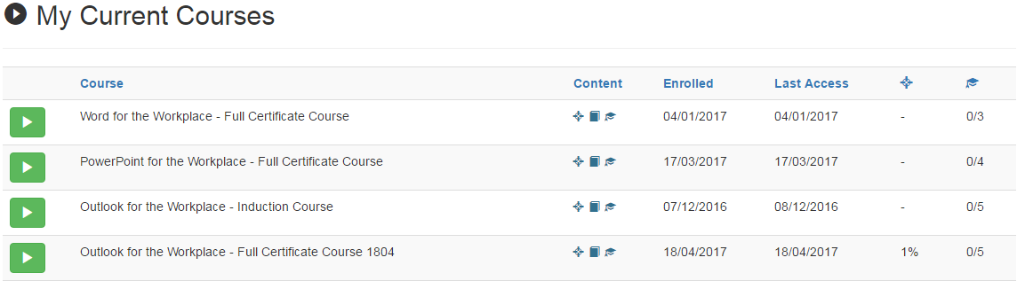
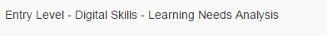
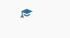
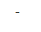
Diagnostic Scores are displayed here
Hover over these icons to see the Course Content

From the Current tab you can see any courses you are currently enrolled on. You can launch your learning from here.

Assessment Passes are displayed here
Click to sort by column headings

Launch courses here

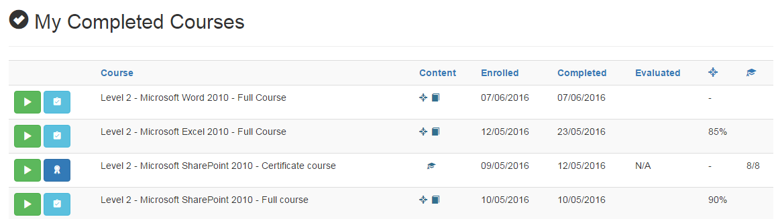
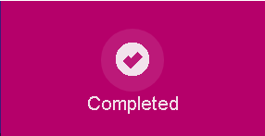
From the Completed tab you can see your achievements, evaluate the courses and print your certificates.
Launch the course to recap here
Hover over these icons to see the Course Content

See your Diagnostic and Assessment passes here
Evaluate the course and print Certificates here
Click to sort by column headings


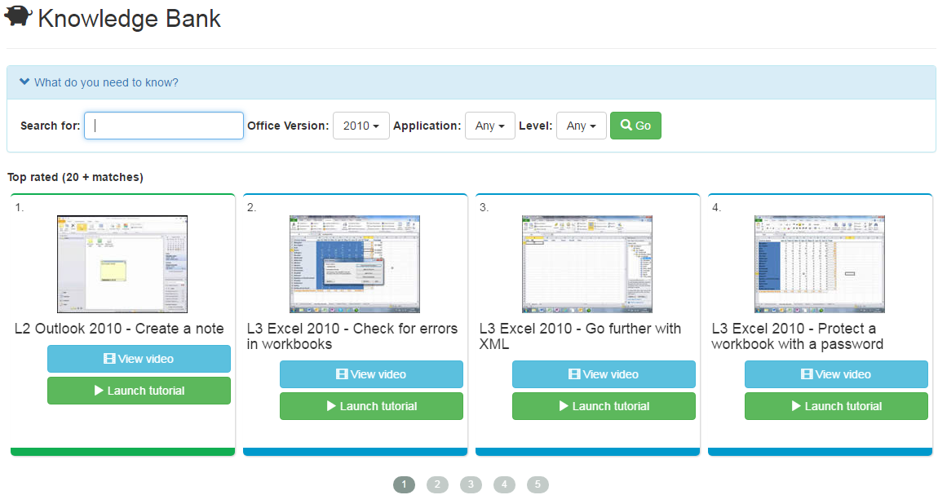
From the Knowledge Bank you can search for bite-size tutorials and videos.
Type your Search here
Use the Filters to refine the results
Then click Go
The results will appear here, you can click to launch videos and tutorials
There may be a number of pages of results depending on your search. You can view all the results by clicking on the numbers here
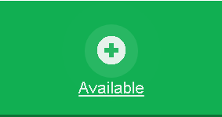
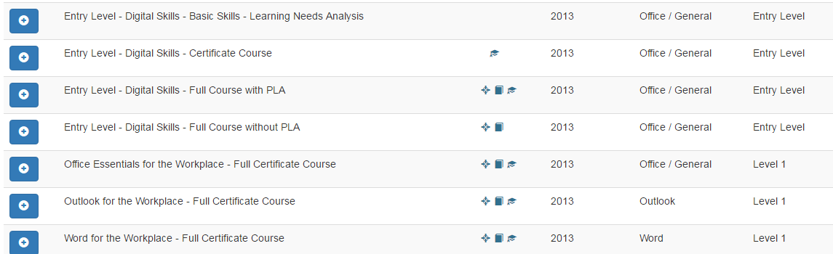
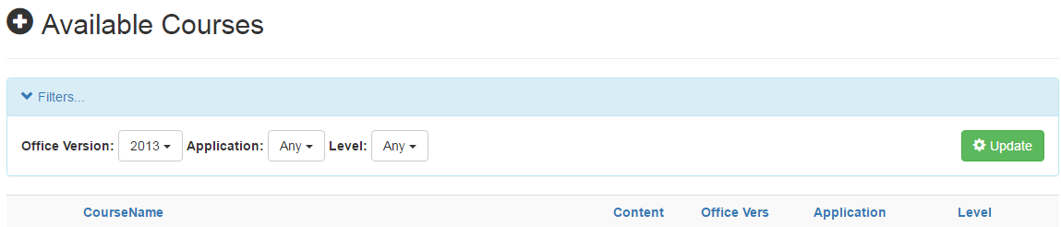
Click this button to re-enrol on a course you have previously started and not visited for a while. The course is now available in Current
From the Available tab you can book directly onto other courses that may be of interest to you. If there is a course you’d like to do and you can’t see it here please contact us.
Click to sort by column headings
Apply Filters to search for courses and then click
Click on the course enrol button to start a course. The course is now available in Current
Hover over these icons to see the Course Content

Office Version, Application and Level are displayed here
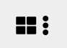
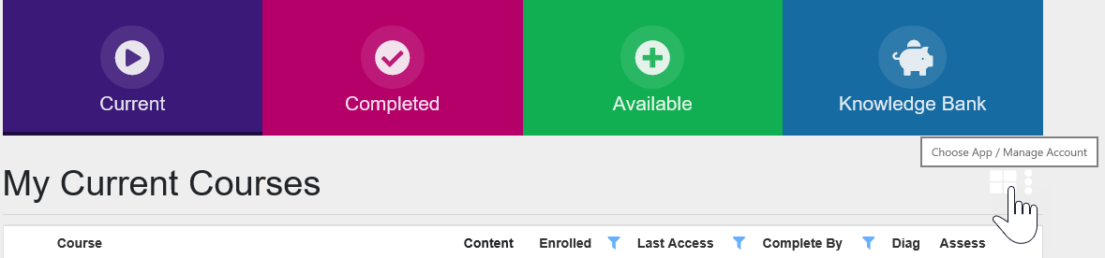
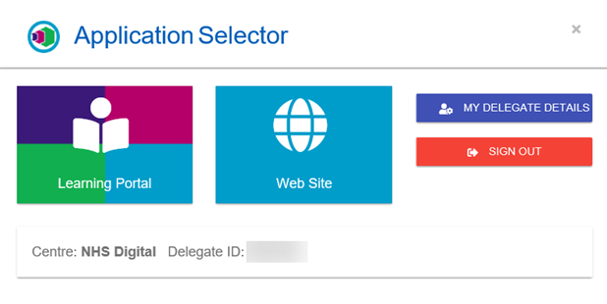
When you’re ready to leave the Learning Portal you’ll need to SIGN OUT
Then click SIGN OUT
To return to the Application Selector click here

From MY DELEGATE DETAILS you can set your notification preferences and manage your password
Access the Digital Learning Solutions Web Site here
Changed your mind? Return to your Learning Portal here

